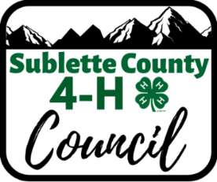
Sublette County 4-H Council
Livestock Committee Meeting
Tuesday, February 21st, 2023
Extension Office
6:15 pm

- Call Meeting to Order: 6:20
- Attendees: Jen Hayward, Russell Burton, Jenna and Phil Mergl, Dale Kaan, Coke Landers, Jana Hughes, Grant Whitman, Dru Rogers, Steve Green, Anna Campbell, Dagan Montgomery
- Old Business:
  - 4H Barn
Updates to barn agreement added, and this committee should enforce maintenance and proper usage. A dry erase board will be used for check ins.
Dale Kaan appointed superintendent. Superintendent and educator will perform routine check-ins.
  - Beef Fitting Clinic
March 17th/18th selected for dates, $500 travel plus hotel to be paid to Herschel. It was mentioned that there could possibly be a hoof trimming before at a set price to be determined.
It was decided that Cody Post will need to determine more specifics such as price and location at the fairgrounds.
  - 4H Barn Scale Parts
    - A new scale may be needed for the simplest fix, options are $499 for 2,200 lb. scale, $320 for 660 lbs. scale, 0r replacement parts for $250.
It was moved and seconded to purchase the $320 scale for the barn. Motion passes.
  - EID Wand purchase
Options range from $300 to $2,300. Gallagher brand services their equipment and can be bought for $1,790 with Bluetooth and Excel capabilities. The cost could be split between the committee, fair board, sale committee and FFA.

It was moved and seconded to go forward with $1,790 purchase if the cost could be split 3 to 4 ways between the aforementioned parties.
  - Beef Tagging Day issues
Jana brought up concerns regarding people unwilling to attend club tagging’s and how this needs to be enforced in the future.
- Next Meeting: June 6th, 6:15
- Adjourn: 7:30

